INFORMATION REQUESTED

If you have had any personal experiences, captured any EVPs or anomalies in your photos, please let us know so we can add them to the list of happenings at each hunt site.

GROUP NEWS

We would like to thank everyone that helped with the planning, preparations and set up for the Masquerade Ball held on August 27 at The Anchorage. Everyone’s help is greatly appreciated. For those that were unable to attend this ball you missed a great time. If you did attend and you have any pictures you would like to share with us, please let us know.
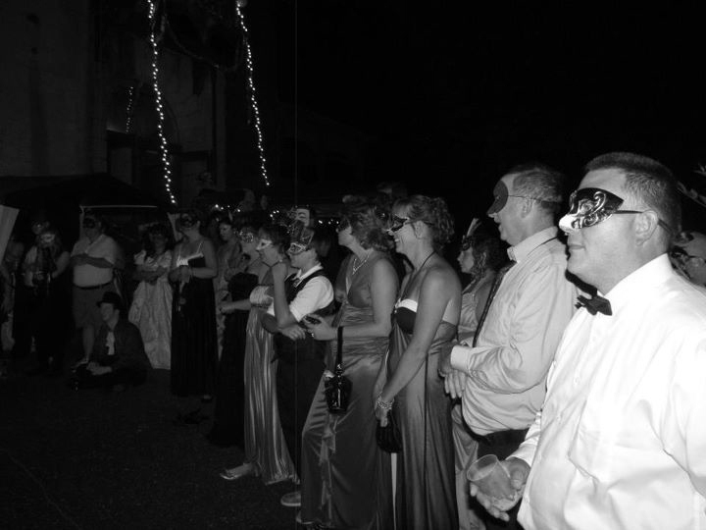
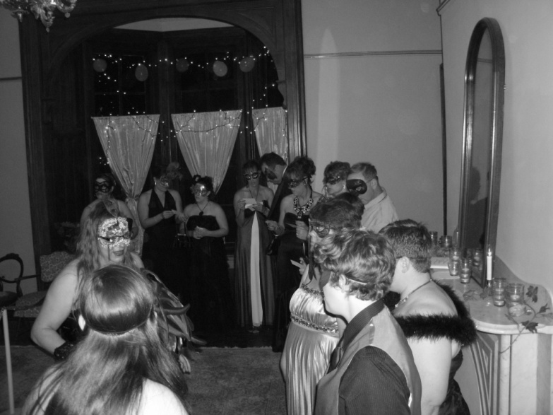

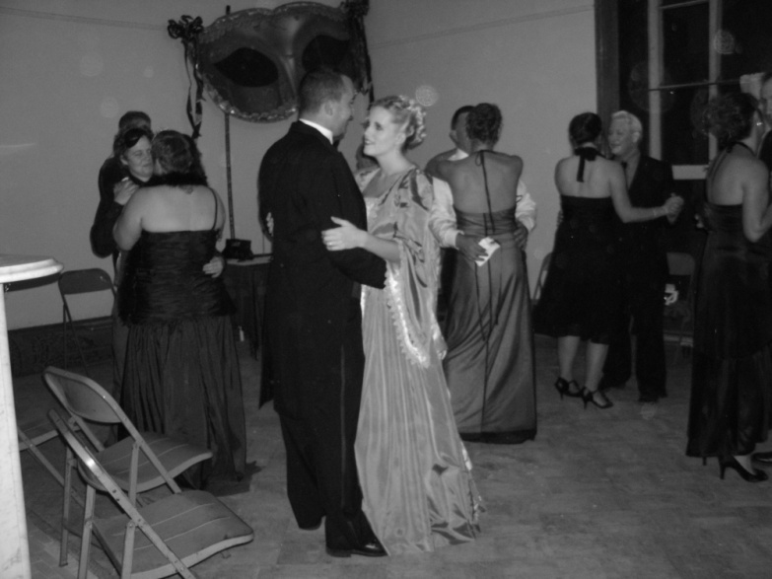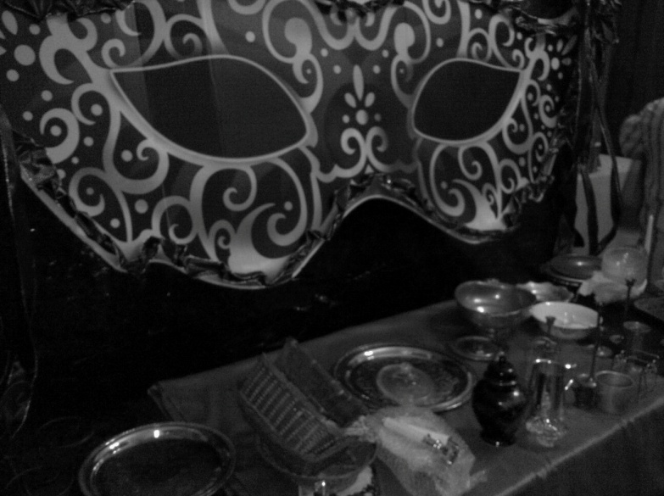

PARANORMAL NEWS

Nothing exciting seems to be in the news regarding the paranormal. However, with October and Halloween just around the corner, I’m sure that will change very soon.

COMMUNITY NEWS

Psychic Development with Guy Lockhart and Susan Sheppard & Sacred Way Astrologers is held every Tuesday at 7 pm at the Dils Center, 521 Market Street, 2nd Floor Conference Room, Parkersburg, WV. Cost is $5 per night.

****************************

There are area activities planned by local businesses throughout Moundsville for before the Zombie Walk. There will be a street fair and special menu items available only on that day. The first Moundsville Zombie Walk is being held September 24, 2011, from 6 pm to 9pm and will start and end in front of the penitentiary. The cost for the walk is a non-perishable item. After the walk there will be a dance for those who wish to participate of Michael Jackson’s Thriller in front of the Penitentiary.

There will also be a Masquerade Party at 9 pm until midnight with the band Maxxtech and the cost for it will be $10. These tickets are limited to 500 and are now available on www.wvpentours.com. Watch their Facebook page for updates.

****************************

Check out the calendar for additional community activities for the month.

QUOTE

“I have no special talents. I am only passionately curious.”
Albert Einstein

JUST FOR A CHUCKLE

Do you have any suggestions? Drop me a line so I can add it to the newsletter.

HISTORY AND GHOST STORIES OF SCHEDULED HUNTS

(Please remember that all hunts are subject to the weather)

The Anchorage

Overlooking West Marietta/Harmar is the imposing ashlar sandstone Italian villa known as "The Anchorage" or "Putnam Villa". This home, built in 1859 by Douglas Putnam for his wife Eliza, comprises 22 rooms and a grand tall campanile that fronts the house. From the tower room, the largest part of Marietta and its two rivers can be viewed. John Slocomb was the architect and master builder. The walls are made of 24" thick sandstone quarried from the top of the hill behind the house. The foundation is of solid rock and all wood used in the house is locally grown oak.
The Anchorage is best remembered as Edward MacTaggerts residence. Using wealth accumulated from oil wells in Oklahoma, Mr. MacTaggert restored the home and furnished it with treasures from his many worldwide travels. From the tower room, the largest part of Marietta and its two rivers can be viewed. This mansion served as the residence of many prominent Marietta citizens including Harry Knox (Knox Boatyard), Dorothy James Roberts (author, and Sophia Russell (Marietta College). The mansion is currently undergoing restoration sponsored by the Historical Society.
There have been reports in the past of EVP’s, individuals being poked, clothes being raised up, giggles, shadow people, voices, footsteps, among other things. There are also pictures of a little girl standing in the attic.

This hunt will cost $15 per person. All proceeds are donated to the Historical Society to further their efforts for restoration.

HUNT REVIEW

Moundsville

HUNTS IN THE COMING MONTH

The Anchorage – October 7, 14, 21 and 28th. All of these hunts are open to the public and there is a limit of 25 people for each hunt. The cost is $15 for each person and you will need to purchase your tickets ahead of time.

BOOK SUGGESTIONS

Amy Good suggested two books for this month. One of them is “Ghosts of Marietta” by Connie Cartmell. The second book is “Haunted Valley” by James Gay Jones. They are both very interesting books, well worth the read.

MOVIE SUGGESTIONS
Joann Norman suggested the movie “The Rite”. I have also seen this movie and it is a very good movie, well worth the watch.

ARTICLE SUGGESTIONS

Melinda Fulk suggested the following article: The Well-Traveled Ghost Hunter: Ghosts From Around the World. The article can be found at http://www.llewellyn.com/journal/article/2235. It is interesting article with a different look at some usual ideas.
TELEVISION SHOWS/EPISODES

Carlene Lyons suggested watching the episode of Celebrity Ghost Stories – The Haunting of Loretta Lynn on the Bio Channel. With October coming up I’m sure you will be able to view this episode as well as many others.

WEBSITE SECTIONS

Do you have any movie suggestions? Drop me a line so I can add it to the newsletter.

