MARCH 2013 NEWSLETTER

GOT GHOSTS?

If you have or know of someone that needs help with unknown happenings in their home or business, just let us know.

We can schedule an investigation of the site and give you our determination of what may be happening.

We do not charge for our services.
ARE YOU READY FOR 2013

GROUP SPEAKING EVENTS

April 6 – 10 am to ? - The Unexplained: Bigfoot, UFOs and Paranormal Activities – Crossroads Branch Library, Cambridge, OH - Free to the public.

PARA PHOTOS & VIDEOS

If you haven’t done so, check out the pictures and videos that James Moore posted that were caught in the Anchorage. You can find them on his facebook page or on our group facebook page and on you tube. They will blow your mind.

OTHER PARANORMAL ACTIVITIES
Overnight hunts are available at the Anchorage for $35 per person with a minimum of 5 people and a maximum of 10 people. There is a $50 non-refundable deposit due once the date of your private hunt is approved with the balance due no later than 2 weeks prior to the hunt. Contact Tom Moore to book your hunt or send us a message on Facebook.

HELP WANTED – Do you have something you would like to see in our newsletter? I would love to keep the newsletter going and growing, but I need your help. If you would like to add something to the newsletter, please e-mail it to me at valerie.movgh@gmail.com. Any and all help will be greatly appreciated.

ATTENTION: Do you have EVPs or experiences from a hunt you were on? We are trying to keep track of things that happen on the hunts to watch for reoccurring events. Please get with someone with your story or EVPs so we can add them to our list. You will receive all credit for any EVPs, pictures and experiences.

Something to think about – Is there a difference between
a ghost and a spirit? What do you think?
COMMUNITY NEWS

2/12/2013 - 3/05/2013 - Drawing Class - Riverside Artist's Gallery, Marietta, OH

2/22/2013 - Annual Juried Student Exhibition –
Marietta College Hermann Fine Arts Center
3/01/2013 - 3/02/2013 - Guild Builders - The Musical Adventures of Flat Stanley Jr -
Actors Guild Playhouse, Parkersburg, WV

3/01/2013 - 3/02/2013 - The Arabian Nights –
Marietta College Hermann Fine Arts Center

3/02/2013 – Celtic Celebration – Wheeling, WV

3/02/2013 - Winter Market – WVU-P Downtown Center, Parkersburg, WV
3/02/2013 - "A Melting Pot of Jazz" Series – The Castle, Marietta, OH
3/03/2013 - Sunday in the Park – North Bend State Park, Cairo, WV

3/03/2013 - The Arabian Nights –
Marietta College Hermann Fine Arts Center, Marietta, OH

3/03/2013 - West Virginia Symphony Orchestra - Apocalyptic
Blennerhassett School, Parkersburg, WV
3/06/2013 - Oil Painting for Adults – Riverside Artists Gallery, Marietta, OH
3/08/2013 - 3/10/2013 - Guild Builders - The Musical Adventures of Flat Stanley Jr Actors Guild Playhouse, Parkersburg, WV
3/09/2013 - The Secret Garden – Parkersburg Art Center, Parkersburg, WV

3/10/2013 - Friends of the Museums Spring Program –
Campus Martius Museum, Marietta, OH
3/13/2013 - Oil Painting for Adults – Riverside Artists Gallery, Marietta, OH
3/15/2013 - 3/17/2013 - Women's Getaway Weekend –
North Bend State Park, Cairo, WV
3/16/2013 – Pampered Chef Bingo - Belpre, OH

3/16/2013 – Emerson Designer Purse Bingo- Parkersburg, WV

3/16/2013 - 3/24/2013 - Mid-Ohio Valley Heritage Quilt Show
Blennerhassett Museum, Parkersburg, WV
3/17/2013 - 3/22/2013 - Quilter's Retreat North Bend State Park, Cairo, WV
3/17/2013 - Sunday in the Park - North Bend State Park, Cairo, WV
3/17/2013 - Winter Salon Series - Trillium Piano Trio - The Castle, Marietta, OH
3/20/2013 - Oil Painting for Adults – Riverside Artists Gallery, Marietta, OH

3/23/2013 – Parkersburg Easter Parade - starts at 2 PM
3/23/2013 - Family Easter Tea and Tour – The Castle , Marietta, OH

3/22/2013 – 3/24/2013 – Horror Hound Weekend – Cincinnati, OH
3/30/2013 - Welcome Back Carp - Ohio River Museum, Marietta, OH
The Washington County Historical Society holds their monthly meeting on the first Monday of every month in Marietta at St. Lukes Episcopal Church at 7:30 pm. They do have a yearly membership fee of $20. For more information their website is www.wchs-ohio.org.

The Wood County Historical and Preservation Society holds their monthly meeting on the last Monday of every month in Parkersburg at the Parkersburg & Wood County Public Library at 7 pm. They do have a yearly membership fee of $15. For more information their website is www.wchps.com.

PARANORMAL MOVIES

The Last Exorcism Part 2 – to be released 3/1/13

Phantom – to be released 3/1/2013

And Then You Die – to be released 3/2/2013

Vamp U – to be released 3/5/2013

Evil Dead – to be released 3/8/2013

The Call – to be released 3/14/2013

Bloody Bones – to be released 3/22/2013

The Haunting in Georgia – to be released 4/18/13

Have you seen a paranormal movie lately? Would you be willing to write a review for the newsletter? If so, e-mail me or bring in a written review and I can add it to the newsletter.

Tickets are now available for the 3rd annual Masquerade Ball, to be held at the Anchorage.

Keep the date open for May 18 for a fun filled evening from 8 pm to midnight. Dress in your best for live music, dancing, fun, food and festivities.

Tickets are $25 each; get yours today while they last.
Beginning in april the newsletter will only be available on our facebook page and our webpage. Calendars will available at the monthly meetings as usual.
PARANORMAL NEWS TIDBITS

Zombie Apocalypse announced on Montana emergency alert system.

On February 11 the Montana alert system was hacked into and a notice of dead bodies rising and attacking the living.

E-bay bans all paranormal items.

As of September 1, 2011 E-bay will not allow any metaphysical items to be posted on their site for sale. This includes such things as psychic readings, love potions, witchcraft spells and curses as well as haunted dolls and all haunted items. All items in this category will be removed and the seller will be subject to account suspension or removal and possible banishment.
UPCOMING BOOK PARANORMAL BOOK RELEASES

So You Want To Be A Ghost Hunter - By Rock Island Paranormal – Written by Jason Hess

A New Scientific Perspective on Remote Viewing, Clairvoyance, and Other Inexplicable Phenomena – James D. Stein

Their True Bloody History from New York to California – Dr. Bob Curran

Why People Believe in Spirits, God and Magic – Jack Hunter

Have you read a new book? Submit your review.
Have you seen a new paranormal television series? Please submit your review of the series.
NEW AND RETURNING PARANORMAL TELEVISION SERIES

Stranded – Wednesday at 8 pm on SyFy

Haunted Collector – Wednesday at 9 pm on SyFy

Do you have something you would like added to the bulletin board. Just drop me a line at Valerie.movgh@gmail.com
Do you have any coats, hats, gloves or money you are willing to donate? A group of Ohio University students are collecting coats, hats, gloves or money, to wash everything collected, to be donated to Athens County Grade Schools. If you are willing to donate, please let me know and I will get the items to the appropriate person. I work with one of the mothers.

Valerie

Group T-shirts $20 each (we must have a minimum of 12 orders to order printing)

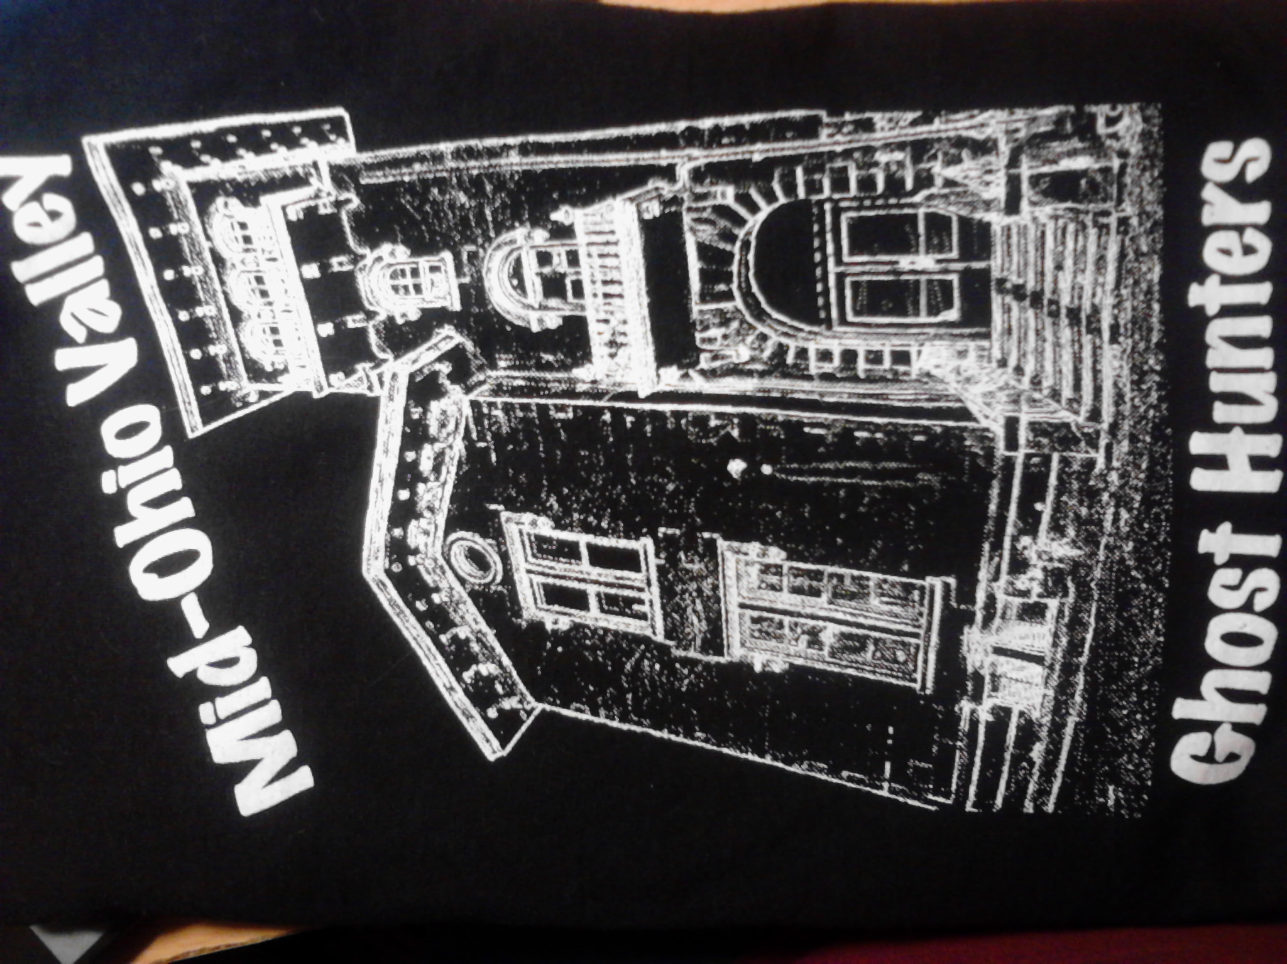

BULLETIN BOARD

