JUNE 2013 NEWSLETTER

GOT GHOSTS?

If you have or know of someone that needs help with unknown happenings in their home or business, just let us know.

We can schedule an investigation of the site and give you our determination of what may be happening.

We do not charge for our services.
ARE YOU READY FOR SUMMER

GROUP SPEAKING EVENTS

Nothing scheduled for May

Are you a member of an organization and would like someone from our group speak at your meeting, please contact us.

May’s monthly meeting review

At May’s meeting we had a large attendance of 28 people.

Our meeting consisted of discussing upcoming investigations. We also discussed our most current past investigations and some of the experiences and EVPs that we caught on those investigations.

The main program for the evening was by Bill Sargant, he presented information on the different types of cameras used in ghost hunting. He also shared some of the photos that he has captured at many of our investigations.

We announced that we will be discussing protection during ghost hunting and options of protection.

To end the meeting we had an open discussion and answered any questions.

PARA PHOTOS & VIDEOS

If you haven’t done so, check out the pictures and videos that James Moore posted that were caught in the Anchorage. You can find them on his facebook page or on our group facebook page and on you tube. They will blow your mind.

OTHER PARANORMAL ACTIVITIES

Overnight hunts are available at the Anchorage for $35 per person with a minimum of 5 people and a maximum of 10 people. There is a $50 non-refundable deposit due once the date of your private hunt is approved with the balance due no later than 2 weeks prior to the hunt. Contact Tom Moore to book your hunt or send us a message on Facebook.

HELP WANTED – Do you have something you would like to see in our newsletter? I would love to keep the newsletter going and growing, but I need your help. If you would like to add something to the newsletter, please e-mail it to me at valerie.movgh@gmail.com. Any and all help will be greatly appreciated.

ATTENTION: Do you have EVPs or experiences from a hunt you were on? We are trying to keep track of things that happen on the hunts to watch for reoccurring events. Please get with someone with your story or EVPs so we can add them to our list. You will receive all credit for any EVPs, pictures and experiences.
COMMUNITY NEWS

The Washington County Historical Society holds their monthly meeting on the first Monday of every month in Marietta at St. Lukes Episcopal Church at 7:30 pm. They do have a yearly membership fee of $20. For more information their website is www.wchs-ohio.org.

The Wood County Historical and Preservation Society holds their monthly meeting on the last Monday of every month in Parkersburg at the Parkersburg & Wood County Public Library at 7 pm. They do have a yearly membership fee of $15. For more information their website is www.wchps.com.

6/01/2013 - 12/15/2013 - Trail Season Opens for Riding - Wayne National Forest -http://www.fs.usda.gov/wayne

6/01/2013 - 6/02/2013 - Family Trails Weekend - North Bend State Park
http://www.northbendsp.com

6/01//2013 - 6/01/2013 - National Trails Day - Fee Waived - Wayne National Forest - http://www.fs.usda.gov/wayne

6/01/2013 - Saturdays On The Square - National Trails - Cairo Town Square

6/01/2013 - 8/31/2013 - Mound Cemetery Tours - The Castle
http://www.thecastle.edu

6/01/2013 - 6/02/2013 - Julia-Ann Square Home and Garden Tour & Tea
http://www.juliannsquare.org

6/07/2013 – 6/08/2013 - Pioneer Palooza – Muskingum Park

6/07/2013 - 6/08/2013 - Moon Over Mountwood Fishing and Outdoor Festival - Mountwood Park - http://www.mountwoodpark.org

6/07/2013 - 6/08/2013 - National Get Outdoors Day - Fee Waived - Wayne National Forest - http://www.fs.usda.gov/wayne
6/07/2013 - 6/09/2013 - Play Outside Weekend - Wayne National Forest, Public Affairs Office - http://www.fs.usda.gov/wayne

6/08/2013 - 6/09/2013 - Introduction to Mountain Biking - Weekend Classes - North Bend State Park - http://www.northbendsp.com

6/08/2013 - Westward Home “1788 Ipswich to Marietta 2013” – Muskingham Park

6/10/2013 - 6/13/2013 - Styles Mansion Archeological Dig - Mountwood Park
http://www.mountwoodpark.org

6/14/2013 - Jazzin' Up the Museums - Valley Gem Sternwheeler
http://www.campusmartiusmuseum.org

6/14/2013 - Riverside Artists Gallery Participates in Marietta's Downtown Merchants and Artist Walk - Riverside Artists Gallery
6/15/2013 - Living History Program - The Castle
6/20/2013 - West Virginia Day Celebration - Blennerhassett Island
http://www.blennerhassettislandstatepark.com

6/21/2013 - 6/23/2013 - Mid-Ohio Valley Multi-Cultural Festival - City Park
http://www.movmcf.org

6/22/2013 – 6/23/2013 - Sesquicentennial Celebration at Veteran's Memorial Park - http://www.carlinsbatteryd.org

6/22/2013 - Island Frolic with Evening Meal - Blennerhassett Island
http://www.blennerhassettislandstatepark.com

PARANORMAL MOVIES

Rapture-Palooza –
Release date June 7, 2013

The Haunting of Helena – release date June 21, 2013

World War Z –
Release date June 21, 2013

Detention of the Dead – release date June 28, 2013

Have you seen a paranormal movie lately? Would you be willing to write a review for the newsletter? If so, e-mail me or bring in a written review and I can add it to the newsletter.

The 3rd Annual Masquerade Ball was held on May 18, 2013.

It turned out to be a great evening we helped raise money to assist in the continued restoration of the Anchorage.

We had over 40 local businesses donate items for a silent auction for additional money for the continued restoration.

Thank you for those who attended and helped with the preparations.
Have you read a new book? Submit your review.
RECENT AND UPCOMING BOOK PARANORMAL BOOK RELEASES

101 Ghost Hunting Questions – Answered by Fiona Broome

Have you seen a new paranormal television series? Please submit your review of the series.
The newsletter will only be available on our Face book page and our webpage. Calendars will available at the monthly meetings as usual.
PARANORMAL NEWS TIDBITS

Olympia Beer (olympiabigfoot.com) is offering a reward of one million dollars for the capture of Bigfoot. They are partnering with The Falcon Project (thefalconproject.com). The rules for this contest on are the Olympia Beer website. The contest runs until March 31, 2014.

There was a picture taken of a little girl in Kirkland, Ohio, that is fighting leukemia, that some believe shows a spirit in a long red dress standing beside of her. Some people believe the spirit to be the Virgin Mary. This story was aired on Cleveland News and is also written about in the Examiner, an online news site. Check it out for yourself and see what you think at www.examiner.com.
NEW AND RETURNING PARANORMAL TELEVISION SERIES

Paranormal Witness returns June 5

The Haunting of …. returns June 1

Ghost Hunters returns June 12

Celebrity Ghost Stories returns June 1

Are You Being Watched?

Have you ever felt that you were being watched? Who hasn’t at one time or another, right?

Well, now there has been research performed that shows that this felling is just due to the fact that we have been “hard-wired” that way.

The studies shows that people that were asked to look at pictures of people where the eyes were not clearly seen and tell which direction that person was looking in. The people that were studied felt that the people in the pictures were looking at them directly.

There are more studies being planned to help determine whether this is actually due to our evolution or by our genetics.

HUNT REVIEW

THE ANCHORAGE – APRIL 6, 2013

There was an open hunt for our group held at the Anchorage from 8 pm until 3 am.

As usual our favorite site did not disappoint.

We had more activity on that night that we have ever had at any hunt held there. We had reports of people being touched, voices heard, different types of lights being seen, footsteps heard, shadow people seen, mysterious smells and more. There were so many reports of activity that it was hard to keep up with the reports.

Do you want to experience the Anchorage, just let us know? We can book a private hunt for you and your group. The cost is $35 per person with a minimum of 5 people and a maximum of 10. There is a $50 non-refundable deposit required upon approval of your date being available with the balance due no later than 2 weeks prior to the hunt. The private hunts run from 8 pm until 3 am. The money from these hunts goes to the Washington County Historical Society for the continued restoration of the Anchorage.

PARANORMAL RESEARCH GROUP

I found this on Facebook and checked it out. It is completely anonymous as they state. There are about 36 questions to the survey.

The Paranormal Research Group is doing new research on Paranormal Beliefs of Ghost Hunters and Paranormal Investigators. They are looking for both individuals who are and are NOT Paranormal Investigators / Ghost Hunters to take this survey. It’s open to everyone. It is completely anonymous and the results will be presented on their website (paranormalresearchgroup.com) and/or in a published paper within the next year. Your help with this project is greatly appreciated!
The survey can be found here:
https://docs.google.com/forms/d/1-Uc8VSfMp2PVuHYsM2rQHOYCTQ2hNrTMa9PQLzX1Dhc/viewform

If you would like to purchase a copy of the CD of the pictures from the 3rd Annual Masquerade Ball, just let us know. They will be available shortly and will cost $5.00 each.

Group T-shirts $20 each (we must have a minimum of 12 orders to order printing)

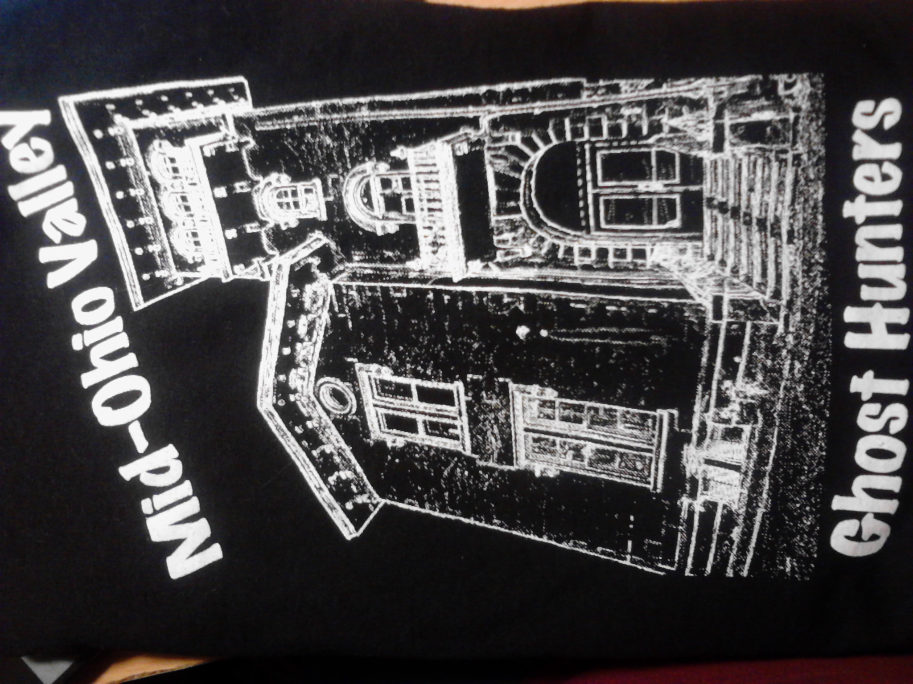

BULLETIN BOARD

