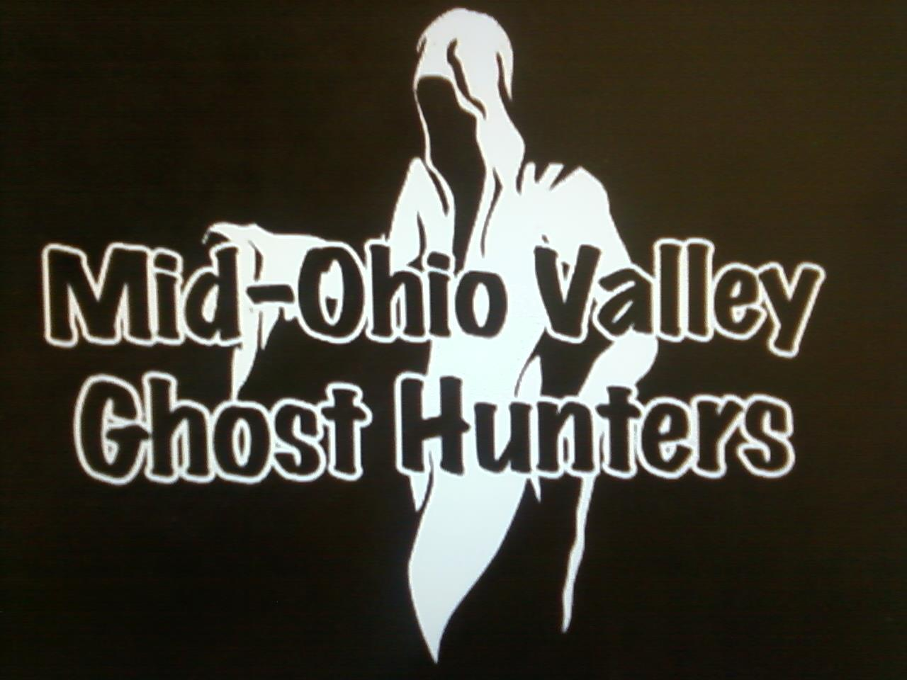

AUGUST 2013 NEWSLETTER

GOT GHOSTS?

If you have or know of someone that needs help with unknown happenings in their home or business, just let us know.

We can schedule an investigation of the site and give you our determination of what may be happening.

We do not charge for our services.
ARE YOU READY FOR FALL

GROUP SPEAKING EVENTS

Nothing scheduled for August

Are you a member of an organization and would like someone from our group speak at your meeting, please contact us.

July’s monthly meeting review

At July’s meeting we had an attendance of 17 people.

We discussed the usual, hunt reviews, upcoming hunts, and upcoming speaking arrangements.

We continued our discussion of protection and possession.

We played a video of the exorcism of Anneliese Michel and discussed the video.

PARA PHOTOS & VIDEOS

If you haven’t done so, check out the pictures and videos that James Moore posted that were caught in the Anchorage. You can find them on his facebook page or on our group facebook page and on you tube. They will blow your mind.

.

OTHER PARANORMAL ACTIVITIES

Overnight hunts are available at the Anchorage for $35 per person with a minimum of 5 people and a maximum of 10 people. There is a $50 non-refundable deposit due once the date of your private hunt is approved with the balance due no later than 2 weeks prior to the hunt. Contact Tom Moore to book your hunt or send us a message on Facebook.. Please share this with your friends.

HELP WANTED – Do you have something you would like to see in our newsletter? I would love to keep the newsletter going and growing, but I need your help. If you would like to add something to the newsletter, please e-mail it to me at valerie.movgh@gmail.com. Any and all help will be greatly appreciated.

ATTENTION: Do you have EVPs or experiences from a hunt you were on? We are trying to keep track of things that happen on the hunts to watch for reoccurring events. Please get with someone with your story or EVPs so we can add them to our list. You will receive all credit for any EVPs, pictures and experiences.

COMMUNITY NEWS

The Washington County Historical Society holds their monthly meeting on the first Monday of every month in Marietta at St. Lukes Episcopal Church at 7:30 pm. They do have a yearly membership fee of $20. For more information their website is www.wchs-ohio.org.

The Wood County Historical and Preservation Society holds their monthly meeting on the last Monday of every month in Parkersburg at the Parkersburg & Wood County Public Library at 7 pm. They do have a yearly membership fee of $15. For more information their website is www.wchps.com.

6/01/2013 - 8/31/2013 - Mound Cemetery Tours The Castle
http://www.thecastle.edu

8/03/2013 - 8/04/2013 -Inland Waterways Festival - Nothing Stops This Train Ohio River Museum - http://www.campusmartiusmuseum.org/iwf

8/08/2013 - 8/11/2013 - Rivers, Trails and Ales - http://www.rtafest.com

8/08/2013 - Brunch with Margaret Blennerhassett - Blennerhassett Island - http://www.blennerhassettislandstatepark.com

8/10/2013 - Living History Program - The Castle –

8/16/2013 - 8/18/2013 - Parkersburg Homecoming Festival - http://www.parkersburg-homecoming.com

8/22/2013 - Brunch with Margaret Blennerhassett - Blennerhassett Island - http://www.blennerhassettislandstatepark.com

8/24/2013 – 8/25/2013 - West Virginia State Honey Festival - City Park –http://www.wvhoneyfestival.org

8/24/2013 - Island Frolic with Evening Meal - Blennerhassett Island
http://www.blennerhassettislandstatepark.com

8/31/2013 - 9/01/2013 - Apple Butter Weekend - Blennerhassett Island
http://www.blennerhassettislandstatepark.com

8/31/2013 – 9/03/2013 – Washington County Fair – Marietta, OH - http://www.washcountyfair.com

UPCOMING PARANORMAL MOVIES

The Mortal Instruments: City of Bones to be released August 21, 2013

Poltergeist the remake will begin filming sometime this fall. There is an article from July 23, 2013 that says they have started casting for the film at that time.

The newest release was The Conjuring – if you have seen this movie and would like to write a review, please email it to me at valerie.movgh@gmail.com

NEW AND RETURNING PARANORMAL TELEVISION SERIES

The newest paranormal show is Mountain Monsters about. It is about a group of West Virginia hunters and trappers that hunt cryptoids in the Appalachian Mountains.

We have had several people ask about
when we will be ordering t-shirts. We must have a minimum order of 12 before this can be done.

If you want a t-shirt please get us your size and your money and we can make the order. We have more than half of an order but we still need a few more.

Have you seen a new paranormal television series? Please submit your review of the series.

PARANORMAL NEWS TIDBITS

Our group was highlighted on Facebook by Para – Normal Guys of Connecticut as one of 13 great Paranormal Groups for the week of July 11, 2013. We were listed on their Paranormal Showcase list for that week in the number one spot. From what I have seen they showcase 13 different paranormal groups each week and ask that people like their Facebook pages to help them get some exposure.

UPCOMING TRAINING – August 31, 2013

We are planning an all day training session at the Anchorage that will include at least the following:

History of the Anchorage and its families
How to find the history of a site
How to review video and audio recordings from a site
A hunt to use the training received.

The cost will be $15 per person for the hunt if you attend the training sessions.

Please invite your friends, this is open to everyone.
The newsletter will only be available on our Face book page and our webpage. Calendars will available at the monthly meetings as usual.

PARANORMAL MOVIE REVIEWS

The Awakening Definitely Kept Me Up
Melinda Fulk

I’m not really one for horror movies, but my husband happened to be watching The Awakening on Netflix the other night and I found myself getting sucked in. Set in 1921, post-war England reeling from all the loss of such many youth. Florence Cathcart has made quite a name for herself exposing spiritualist hoaxers. In due course, she winds up at a remote boys’ school investigating reports of a child ghost. The events that follow proceed to tear about her firmly held beliefs and threaten her sanity.
I’ll admit, part of the pull for me was the time period – I love the 1920s and enjoyed the chance to get a cinematic glimpse of Great Britain at the beginning of the period. However the story, with all the psychological stressors and challenges, was very compelling. If you only like your horror violent and bloody, then this movie is not for you, but if you like a good psychological build-up to the big plot-twist reveal, definitely check it out.
The Awakening, 2011, stars Rebecca Hall (Iron Man 3), Dominic West (John Carter, Johnny English Reborn), and Imelda Staunton (Harry Potter), and was directed by Nick Murphy (Blood).

Pro-Wrestlers vs. Zombies

Oh my gosh! We got to see a pre-post-production clip from the movie at the River City Comic Con in Marietta last month and it looks like pure fun! Tom can feel vindicated in describing the Fort Boreman shooting as COLD! When asked what was the most difficult part of the shoot, director Cody Knotts, said it was the cold during that shoot. It kept burning through the camera batteries. Now, to keep our ears peeled for when the screening in Parkersburg happens. I’m really hoping for a blooper reel at the same time. (http://www.prowrestlersvszombies.com/)
Oh, and the Comic Con was a great time. The entire family really enjoyed it! We’re already talking about going again next year. – Melinda Fulk

HAVE YOU SEEN A PARANORMAL MOVIE LATELY? WOULD YOU BE WILLING TO WRITE A REVIEW FOR THE NEWSLETTER? IF SO, E-MAIL ME OR BRING IN A WRITTEN REVIEW AND I CAN ADD IT TO THE NEWSLETTER

BOOK REVIEWS

Is Your House Haunted? Delivers the Goods, for Free
Melinda Fulk

Ghost and paranormal investigator Fiona Broome has a free ebook available for download as either in either epub (ie. Nook) or pdf format. The book, Is Your House Haunted?, is a fairly straightforward, easy read that seems fairly well organized. Ms. Broome takes the reader step-by-step through determining if the house in question is indeed haunted or perhaps only needs some easier physical fixes to get rid of any unsettling phenomena.
One of the things I really liked about Ms. Broome’s approach to investigating a possible haunting was how she started out by discussing safety concerns. There is a small section dealing with nothing but possible safety issues, including insect and animal droppings, as well as the possibility of carbon monoxide poisoning. Apparently many CO poisoning symptoms can be very similar to those experiencing paranormal phenomena. From the safety warnings, she moves on to a large section of tips on things to check before deciding that things are caused by the spirit world. And then finally she touches on what things to look for when deciding what kind of paranormal activity you might be experiencing. I liked that she stays focused and down-to-earth, even when she’s firmly dealing with the possibility of spirit activity. And again she gives a pretty good series of tips to follow. Ms. Broome tries to stay firmly grounded in experience and results, regardless of what she’s discussing and I think that practical approach would be especially comforting to those not used to dealing with psychic and paranormal phenomena.
In addition to the overall readability of her book, there were a couple of things about it that I particularly liked and found useful. First off, she gives a variety of methods to use when trying to *clear* a space. These are always things that she, personally, has found useful, or they come from someone she trusts. Ms. Broome feels that actual ghost hauntings are fairly rare, although that doesn’t rule out other energy or spiritual activity. Heck, she even tossed out the possibility of some phenomena being caused by a touching of parallel dimensions, which is interesting to ponder.
Secondly, she has one heck of a chapter on orbs. This woman has done a lot of research and experimentation on how to interpret those glowing, ghostly spheres that show up on our cameras and gives some great advice on how to figure out what you’ve got, be it dust motes, pollen, a reflection or something else. She includes some advice on ghostly mist and possible causes of what may look like mist, but isn’t really.
And finally, there are several tips on how to protect yourself from negative, or darker, more malevolent energies, including demons. Oh, and there’s even some info on how to deal with poltergeist activity, which was very reassuring and helpful.
Just as there were things I really liked about the book, there were also some things that drove me nuts. For starters, she can be a bit repetitive on certain topics, such as getting out of the house immediately if you feel you are in any danger. (And leaving it even faster if it’s a child feeling threatened.) Okay, I get it. Don’t stay in the house. I could see mentioning it a couple of times, but she does so nearly a dozen instances during the course of the 130 pages (epub version). I think that’s getting a wee bit excessive and starts to cross over into the realm of being preachy.
She’s the same way when reminding us that we can’t scientifically prove that ghosts exist. We can only document and deal with the phenomena at hand. It’s obvious that she believes in the spirit world and the possibility of ghosts and it seems fairly safe to assume that most readers feel the same way, so it shouldn’t be necessary to bring the point up almost as often as telling folks not to stay in the house if they feel in danger. (Honestly, while logical and fairly scientific in its methods, following all of her suggestions could get to be expensive.)
Also, she’ll tell you how to deal with certain things, like getting rid of an Ouija board or other occult objects, by either burying them or tossing them in running water. She’s quite emphatic that you shouldn’t burn them, but never explains why. It might seem like I’m nitpicking, but she’s so insistent about it that I wanted to run right out, buy an Ouija board and then torch it just to see what happened. Satisfying the reader’s curiosity on the reasoning would have been helpful.
What I consider the final negative to the book concerns her tips on finding a ghost hunting group to help investigate. There’s some good advice in there, but I also think she goes overboard on suggesting what credentials your chosen group possess. Bonded? Really? It would be nice, but how many people can afford to go through that process, especially when she thinks they shouldn’t charge anything for their services other than travel.
As a nifty bonus, there’s a very nice checklist at the very back of the book the lists what she considers the main, or key, things to check in investigating a possible haunting.
There’s a lot in those free pages to seriously recommend this book – even if it had a small purchase cost attached. But for free? You need to go download it, because it’s one seriously big ghost hunting bargain.
So, how does a person get their hands on this wonderful tome? That can be the tricky part – the website with the download isn’t all that user friendly, so I’m going to include some tips to hopefully make it painless.
You’ll need to go to The Author’s Club (http://the-authors-club.com/) and create an account. I recommend doing this on a computer or tablet, because it’s so much easier.
Once you’re in your account, you’ll need to check out the non-fiction tab, where you can easily find the book. Is Your House Haunted? is under the Ghost Stories and Paranormal category.
I realize most of this is straightforward so far, but the next bit, after you complete the purchase isn’t. There is no confirmation that comes up on the screen, which can be very confusing. Nor is there an easy indicator of where to go to in order to download your book. There are two ways to get your hands on it. You can either check your email for the order confirmation and a link for the download or hover over the Log-in/Registration tab and click on the Customer Account link. You’ll want to click next on your order number, which will finally give you a download link.
As you can maybe tell, the website isn’t all that intuitive, although there are quite a few more books up now than when I initially downloaded Is Your House Haunted?. If you want more info on Fiona Broome, or you’d like to check out some of her other books, she has a website at hollowhill.com.

HUNT REVIEWS

Old South Pittsburg Hospital – we had a total of 6 people in attendance. We performed a couple of re-enactments on the premises. One was of an emergency room scenario and the other one in the psych ward. Bother were a blast.

Twin City – we had a total of 8 people in attendance.

The Anchorage – we had a total of 18 people in attendance of the first public hunt of the year.

North Bend Tunnels – we had to cancel this hunt due to several different people having other requirements of them. We will reschedule.

LOCAL PARANORMAL OCCURENCES

Courtney Alden observed and recorded an unexplained light over Marietta, Ohio on July 28th. Maria Sargent was with Courtney and witnessed the light as well. The light stayed in the same spot for almost 7 minutes, close to 10 pm. She knew it was not a helicopter because it didn’t move like one and a helicopter flew by in the beginning of the video. She also knows that it was not a light tower of any kind. She said it seemed to move like a drone.

According to comments that she received at the time of her posting if anyone else had seen the same thing, the lights were also spotted in Belpre and Little Hocking on the same night.

Something similar was spotted in the Columbus area three nights before.

She has posted her video on her Facebook page and on YouTube. Check it out. The light seems to change colors, I saw blue, gold, white, red and a little purple. What could this be? Could it be aliens? Could it be she was recording a star burning out? Who knows? What do you think?

THE BLUE MOON

The next blue moon will occur in August 20 and 21, 2013.

A blue moon is the second full moon to occur in a month and is also the third full moon to occur within a season as stated by the Farmer’s Almanac.

The blue moon was also the name of an early moon that had not been given a folk name.

The first occurrence of the moon being called a Blue moon seems to be in a proverb that was quoted in the Oxford English Dictionary in 1528. The proverb reads as follows:

If they say the moon is blue,
We must believe that it is true.

The saying was like saying the moon was made of green cheese, which as everyone knows is not so.

The saying “until a blue moon” changed meanings in the 19th century and was another way of saying “never”. Now the saying is “once in a blue moon” which means every now and then or rarely.

The occurrence of two full moons in one year happens every 19 years. The next year that will have two blue moons in the year will be 2018.

So do you think the Blue Moon will have any effect on ghost hunts?

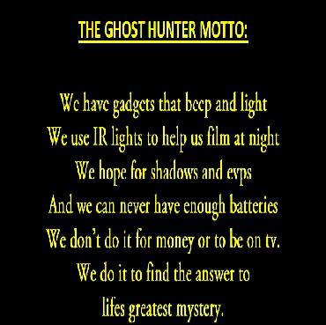

Suggestions or criticisms please email me. I am looking for ways to GROW this newsletter. Do you know of an upcoming paranormal event or anything you think would be interesting, please forward me the information.

Are you a member of another group and would like for us to add your logo and/or link to our newsletter. Please feel free to email that info to me as well. I will gladly add it to our newsletter.
If you would like to purchase a copy of the CD of the pictures from the 3rd Annual Masquerade Ball, just let us know. They will be available shortly and will cost $5.00 each.

Group T-shirts $20 each (we must have a minimum of 12 orders to order printing)

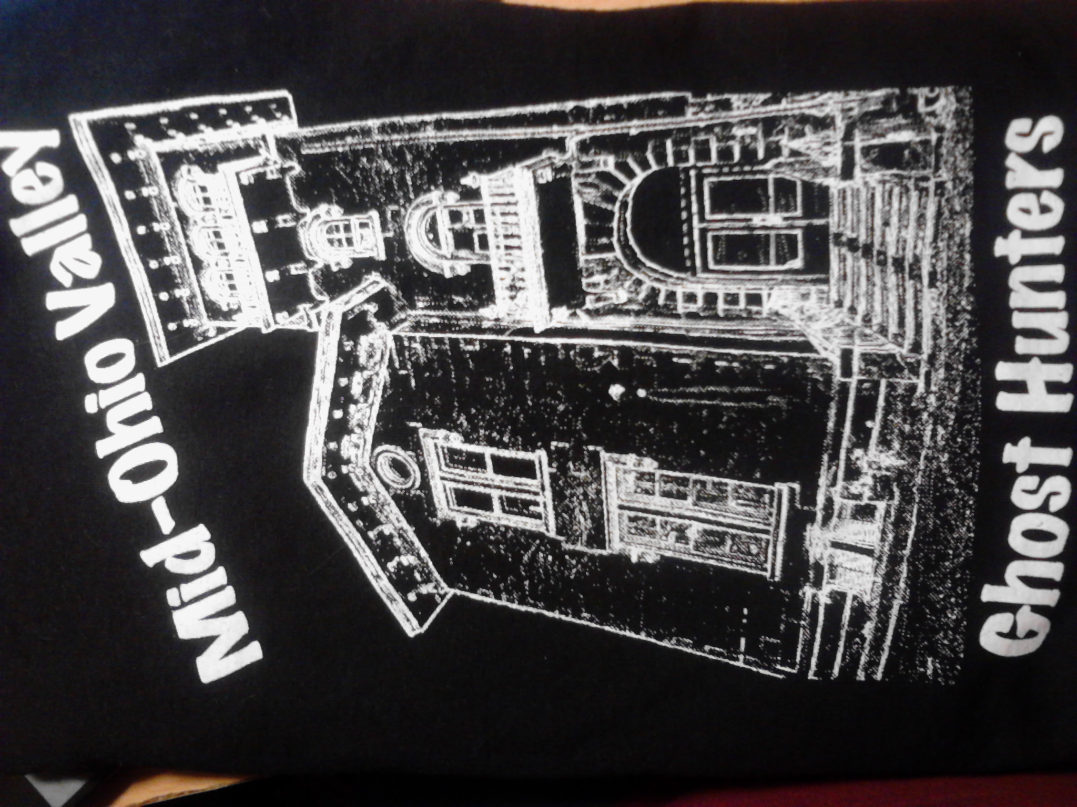

BULLETIN BOARD

